**Lutheran Women’s Missionary League Indiana District**

**Fort Wayne East Zone**

**Fall 2021 Newsletter** Barb Hamm, Editor

**Fort Wayne East Zone President**

*We love because He first loved us (*I John 4:19).

When you think of the word ‘tenderness’, what image comes to your mind? The eyes of a young father as he gazes at his newborn son or daughter? The pads of a kitten’s paw as it taps your cheek? The gentle arms and warm lap of your grandmother holding you many years ago? A realization came to me recently concerning why I love the Bible texts about Jesus’ interaction with women.

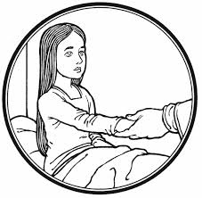

Mark’s gospel shares how Jesus healed the woman who had suffered for twelve years. ‘Then He spoke to her, “*Daughter, your faith has healed you. Go in peace.*” Can you picture that scene and imagine the tenderness of His voice? His next stop was the home of Jairus, whose daughter had died. Jesus took her by the hand and said, “*Little girl, I say to you, get up.*” Or think about the passages in the gospel of John sharing Jesus’ interactions with the Samaritan woman at the well and the woman caught in adultery. Jesus did not condone their past sins, rather He gave them hope for a better life because of their encounter with Him. I picture Jesus speaking with tenderness each time. Jesus refers to them as ‘woman’, not in a derogatory way, but simply as He referred to His own mother. From the cross He cared for her by saying, “Dear woman, here is your son (the disciple John).”

Our culture today is sadly lacking the virtue of tenderness. The media bombards men and women alike with negativism and unpleasant images. Jesus taught us on the night before His crucifixion, *A new command I give you: Love one another. As I have loved you, so you must love one another. By this all men will know that you are my disciples, if you love one another* (John 13:34-35). My prayer for each of you is to follow Christ’s example of being tenderhearted in word and deed, starting with your own family. Then may your tenderness grow to include your friends, your brothers and sisters in Christ, and beyond. As LWML members, may you give your mites and your gifts of time and treasure out of love for those for whom Christ died.

Your sister in Christ,

Elaine Nahrwold

**Zone Counselor**

**New and Old**

Under the jurisdiction of the **Old** Covenant is prophesied the **New** Covenant..*Behold, the days are coming, declares the Lord, when I will make a* ***new*** *covenant with the house of Israel and the house of Judah* (Jeremiah 31:31). The **old** covenant of circumcision under the Law gives way to the **new** covenant of Baptism under the Gospel. The **old** covenant of Passover sacrifices under the Law give way to the cup of the **New** Covenant in Christ the Passover Lamb's blood under the Gospel. The **Old** Testament promise of the Messiah has its fulfillment in the **New** Testament incarnation of Christ.

*Therefore, if anyone is in Christ, he is a* ***new*** *creation. The* ***old*** *has passed away; behold, the* ***new*** *has come* (2 Cor. 5:17). For *as many of you as were baptized into Christ have put on Christ* (Gal. 3:27). *We were buried therefore with him by baptism into death, in order that, just as Christ was raised from the dead by the glory of the Father, we too might walk in* ***new****ness of life* (Rom. 6:4). Therefore, *we are released from the law, having died to that which held us captive, so that we serve in the* ***new*** *way of the Spirit and not in the* ***old*** *way of the written code* (Rom. 7:6).

*Then I saw a* ***new*** *heaven and a new earth, for the first [****old****] heaven and the first [****old****] earth had passed away. And I saw the holy city,* ***new*** *Jerusalem, coming down out of heaven from God. And I heard a loud voice from the throne saying, “Behold, the dwelling place of God is with man, and they will be his people, and God himself will be with them as their God. He will wipe away every tear from their eyes, and death shall be no more, neither shall there be mourning, nor crying, nor pain anymore, for the former things have passed away.” And he who was seated on the throne said, “Behold, I am making all things* ***new****.” Also he said, “Write this down, for these words are trustworthy and true.*” (Rev. 21:1–5).

INDEED, as Jesus says, “*every teacher of the law who has been instructed about the kingdom of heaven is like the owner of a house who brings out of his storeroom* ***new*** *treasure as well as the* ***old*.”** (Matt.13:52). May the Lord continue to bless us with his Law and Gospel in discerning the great mysteries of Christ our Lord incarnated and crucified for us, here in time, for there in eternity.

Rev. James Gier

**Ascension Lutheran Church – Fort Wayne**

Our Mary Martha Guild meets in the evening on the 3rd Monday each month, except in January and February we meet on the morning of the 3rd Saturday.

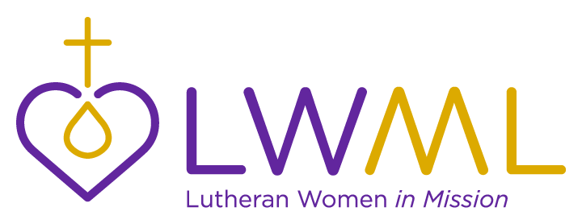

In September we met for devotions and prepared for LWML Sunday. On LWML Sunday small coin bags were given to the congregation to collect mites that morning. We also set up a table with information and Mite Boxes. At our October meeting we made new ribbon markers for hymnals and worked on kitchen labels. We also collected food and clothing for the CTS Donation Day and hosted the LWML Fort Wayne East Zone Rally..

President Karen Blank of Fort Wayne Lutherans for Life spoke to our group in November, and we had election of officers. Our December meeting was cancelled due to Covid concerns, but we did have The Giving Tree to collect gift cards for the CTS Christmas Marketplace.



In January Rev. Zieroth led our Breakfast Bible Study, “The Light Shines in the Darkness - a study of Epiphany.” Our February Breakfast Bible Study was led by Rev. Gier “Good and Evil Angels.” We hosted the Ladies Lenten Devotion “Come Follow Me” in March. At our April meeting we enjoyed a trivia quiz about Lexington, Kentucky, where the LWML Convention was to be held in June. We also marked Bibles for prison ministry and tied blankets for missions. In May we held our 12th Annual Salad Supper Game Night, with games prepared by Elaine Nahrwold. A Ladies Night Out at Zianos finished our year in June.

Three ladies attended the LWML Convention, two attended the district retreat, two attended the Treatshop, and five attended the Three Zone Rally.

.Judy Huber

___________________________________________________________

**Christ Lutheran Church – Woodburn**

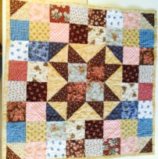This past year the Christ Lutheran Women's group has remained inactive. Other committees associated with the women's group include the funeral committee which provides meals for the family following a funeral, the prayer chain for various prayer requests, and the sewing committee which assembles and knots comforters for missions. This past year, 60 comforters were sewn and sent to various agencies in the US and abroad. The church's LWML continues to collect mites for missions. God's blessings to all the women of LWML

Diane Sargent

**Concordia Lutheran Church – Fort Wayne**

Concordia does not currently have an active LWML group, but they receive *The Lutheran Woman’s Quarterly,* and two ladies attended the Fort Wayne East Zone rally in 2020 and the Three Zone Rally in 2021.

Sally Nyland

___________________________________________________________

**Emanuel Lutheran Church - New Haven**

The ladies of Emanuel continue to serve the Lord with gladness. Emanuel’s ladies’ society consists of circles that serve the people of our congregation and beyond. There is a morning Bible study led by Pastor Zeckzer, an altar circle, a Christian welfare circle that sends the bulletin and newsletter to the shut-ins each week and special cards on holidays, a quilting circle, and a Lutheran World Relief (LWR) quilting circle that knots quilts for various ministries including Point of Grace in Kenya as part of Emanuel’s congregational mission to the children there.

The ladies’ society also has monthly committees that serve funeral dinners as needed and committees that plan and implement our bi-annual rummage sales that raise money that is dispersed to various ministries of the congregation and community. Unfortunately, due to the pandemic, the rummage sales and our bi-annual ladies’ meetings have been postponed for over a year now. We continue to plan for these and hope they will return soon.

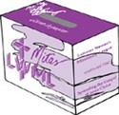Emanuel ladies support the LWML by putting out a purple LWML table on the first Saturday evening and Sunday morning of each month to collect Mite Boxes and share flyers, the *Lutheran Woman’s Quarterly*, and other LWML information. Emanuel was well represented at the LWML Convention in Lexington this June with four ladies and one husband in attendance and volunteering with the host committee. We are excited to host this year’s fall rally and hope that it will expose more women to LWML and equip and encourage them to live as Lutheran Women in Mission.

Renee Schuller

__________________________________________________________

**Martini Lutheran Church – New Haven**

Martini does not have an active society at this time, but hopes to resume activities once everything settles down.

Sue Teasdale

**New Life Lutheran Church – Fort Wayne**

Our Wednesday night free meal for those in need has become in-person again, with a short Bible study at the beginning, thanks to several ladies and the help of deaconesses from the Seminary.

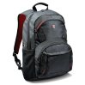We were able to provide the monthly Chris’ Cupboard pantry outreach with appointments and social distancing. We were also able to have a School Supply Giveaway with modifications: backpacks were pre-packed for elementary or middle/high school, families drove up or walked up and told volunteers how many elementary and/or middle/high school packs were needed, and volunteers brought out the needed number. All volunteers wore face masks, hands were sanitized between people, and cars were spaced out for safety.

We are collecting mites again on the first Sunday of the month. One of our Karen Burmese ladies has received Dula training to assist moms-to-be and new moms, and can share Jesus’ love along with human care. Several of the Burmese ladies have taken roles in an evangelistic family relationship video that may hopefully be released soon.

Michele Yamanaka

___________________________________________________________

**Prince of Peace Lutheran Church - Grabill**

Prince of Peace does not have an active society at this time.

___________________________________________________________

**St. Paul Lutheran Church – New Haven**

After the changes made due to Covid last year and the first part of 2021, the ladies of St. Paul are returning to their usual activities. The Ladies’ Christmas and Valentine parties were canceled, as well as the Advent and Lenten meals for the benefit of the Youth Group to attend the National Youth Gathering. Committees have been appointed for the remaining months of 2021 to assist with Rally Day for Sunday School, CLS Sunday and the Advent services in December.

The Ladies Aid Group meets weekly on Thursdays for fellowship, devotions, quilting, knotting baby blankets for A Hope Center, lap robes for area nursing homes, and knotting comforters for Lutheran World Relief, Charis House and the Seminary. We donated a quilt to the 2021 Cadets in Cadence Dinner Auction for Concordia Lutheran High School, collected layette items to send for “Gifts of Love” for the LWML Convention in June, and gathered school supplies to fill backpacks to send to Lutheran World Relief in October.

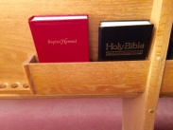The Pew Sisters of St. Paul, about 30 ladies, attended a Bible Study, “The Mighty & the Mysterious” (a study of Colossians by Heidi Goehmann), and Deaconess Grace Randolph led another study discussing the history and content/meaning of various hymns.

Our ladies support St. Paul with a Prayer Chain and Altar Guild. They provided gifts for our pastor and seminarians at Christmas. We also collect and donate items to the Seminary and New Haven food banks. The ladies support the LWML mission grants through our Mite Boxes collected at the beginning of each month.

Brenda Schuller

___________________________________________________________

**St. Peter's Lutheran Church – Fort Wayne**

As we serve our Lord together with gladness we have all been affected by the pandemic. At St. Peter’s we haven’t had an actual meeting, but hopefully will at the end of September.

Meanwhile our Compassionate Care Collections continue. We sponsor these for the congregation to help everyone assist an agency which is helping others. Starting when we could do in-kind collections we have helped Matthew 25, the Rescue Mission, Concordia Theological Seminary, Children of Liberia, and made Lutheran World Relief knotted comforters and Baby Care Kits.

No one was able to attend the LWML Convention.

We thank the Ladies Aid for sponsoring our LWML. They organized in 1934 and have had an LWML since 1942. Stay safe, stay praying,

Elise Koenemann



**Zion Lutheran Church - Woodburn**

LWML meetings are held four (4) times a year in conjunction with our Ladies Society and mites are collected at each of them. LWML Sunday is observed in October and a door collection is taken for mites. We provide the *Lutheran Woman’s Quarterly* to the ladies throughout the year.

GETWELL.WMF

Our Cheer Committee visits the sick and sends greeting cards to those who are ill or are in need, along with the prayer chain. Several Bible Study groups are available and funeral luncheons are served by the ladies of the church. Baby quilts and baptismal napkins are made for the newborn. Fund raisers are Taco Salads and Nachos at Woodburn’s Day In the Park, Euchre Tournament in the fall, and making/selling peanut brittle in the fall.

Many ladies serve on the Altar Guild which provides candles and oil for the Eternal Light. Food items are collected year-round for the Harlan and Woodburn Food banks and in addition we collect paper products for Concordia Theological Seminary in November. Complete Thanksgiving meals are given to needy families in the community.

The Sewing Circle makes comfort blankets which are given to anyone in the congregation and the community plus they sew cancer pads for the Cancer Society. Goody boxes are sent to the college students, service men and women at Christmas time and food baskets are given to the shut-ins. Monetary gifts are given to Woodburn Lutheran School and various other organizations throughout the year. We thank all our ladies for “Serving the Lord with Gladness.”

Gladys Thiele

__________________________________________________________________________

**Mark Your Calendar**

**Saturday, April 23, 2022** LWML Indiana District Fort Wayne Three Zone Spring Rally

hosted by Fort Wayne East Zone at Christ Lutheran Church, Woodburn

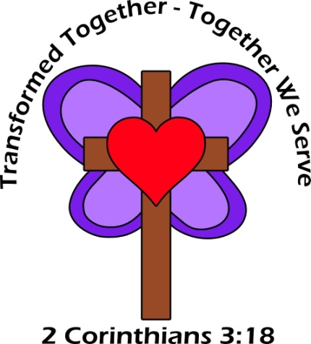

**Friday – Sunday, June 17-19, 2022**, LWML IN District Convention

Concordia Lutheran High School, Fort Wayne, IN

“Transformed Together – Together We Serve”

**Saturday, October 1, 2022** LWML Fort Wayne East Zone Fall Rally

New Life Lutheran Church, Fort Wayne

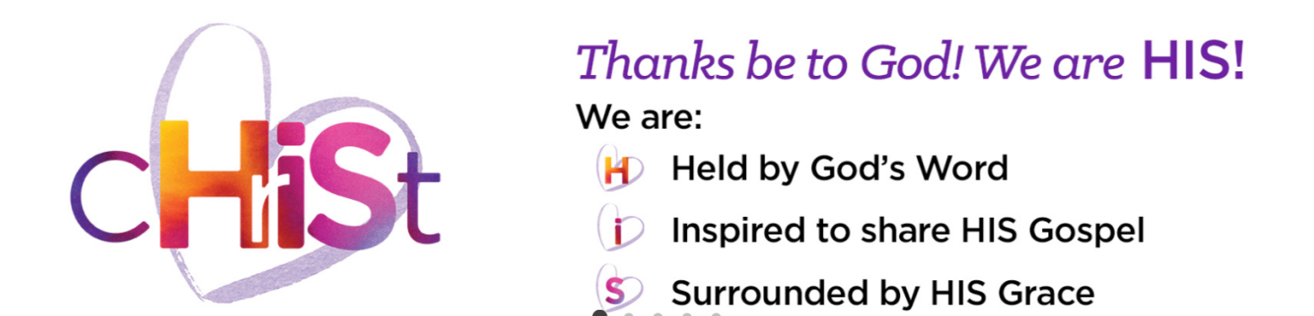

______________________________________________________________________________________

**LWML Indiana District Fort Wayne East Zone Rally**

**October 31, 2020**

**Ascension Lutheran Church, Fort Wayne, Indiana**

The theme “Looking Forward” was based on Philippians 3:13b-14, *Forgetting what lies behind and straining forward to what lies ahead, I press on toward the goal for the prize of the upward call of God in Christ Jesus*.

Judy Huber of Ascension Lutheran Mary Martha Guild welcomed the guests at 9:30 a.m. and Joeline Mayes led the singing of Lutheran Women, One and All.

Rev. Dan Gard, filling in for zone counselor Rev. Tom Zimmerman, gave a presentation on the Old and New Testaments. This was followed by the singing of Jesus, Lead Thou On.

Fort Wayne East Zone President-Elaine Nahrwold opened the meeting and led the assembly in the LWML Pledge.

Secretary/Treasurer Barb Hamm referenced the minutes of the October 2019 rally printed in the newsletter. The financial report showed a balance on hand of $1,218.28. Roll Call was taken. Ascension-11, Christ-2, Concordia-2, Emanuel-4, New Life-4, St. Paul-5, St. Peter-1, Guests-2, for a total of 31.

The report of the Nominating Committee was given by Brenda Schuller. There being only one candidate for President-elect, Cathie Wakeland was elected to that office.

A get-acquainted activity was led by Marsha Zimmerman. Debby Williams distributed prizes to the winners of the following four categories: Oldest member (Helen Brown), least number of residences (Rita Wissman), most nativity sets (Renee Schuller), and most nieces and nephews (Joeline Mayes).

A report of the 2020 LWML Indiana District Convention was given by zone delegate Elaine Nahrwold. Because of Covid, voting for the June 2020 convention was done electronically, following virtual presentations of candidates and Mission Grants.

Marge Gruber, President of the LWML Indiana District presented a power point on Change. She reminded ladies about the district retreat scheduled for April 16-17, 2021 at Jameson Camp, Indianapolis, and the LWML 39th Biennial Convention which will be held in Lexington, Kentucky, June 24-27, 2021, and will be hosted by the Indiana, Michigan and Ohio districts. Many volunteers are needed. A worker form is available on the LWML Indiana District website. Those who volunteer a minimum of eight hours will receive a discount on registration.

Elaine noted zone events listed in the newsletter. Members of our zone currently serving on district positions are Renee Schuller, Recording Secretary, Michele Yamanaka - Heart to Heart District Leader, Cathie Wakeland – Public Relations Director, and Barb Hamm – Structure Committee member.

Helen Brown and Arlys Staub, from Christ Lutheran, presented a skit promoting the 2021 LWML convention. The theme is “Running the Race … Looking to Jesus”

An offering of $325 was received for the Concordia Theological Seminary Student Emergency Fund.

Rev. Gard installed Elaine Nahrwold as President, Brenda Schuller as Vice President, Barb Hamm as Secretary/Treasurer, and Cathie Wakeland as President-elect, and led us in The Litany from the Lutheran Service Book. The meeting closed at 11:15 a.m. with the singing of Serve the Lord with Gladness.

**________________________________________________________________________________________**

**LWML Indiana District Fort Wayne East Zone**

**Financial Report October31, 2020**

Balance on Hand September 30, 2020 **$1,218.28**

Income Mission ingathering 10/31/2020 230.00

Three Zone Rally registrations 108.44

Total Income 338.44

Expenses Concordia Theological Seminary 230.00

Brenda Schuller, delegate to LWML Convention 306.00

Total Disbursements 536.00

**Balance on Hand September 30, 2021** **$1,020.72**

Barbara Hamm, Fort Wayne East Zone Secretary-Treasurer

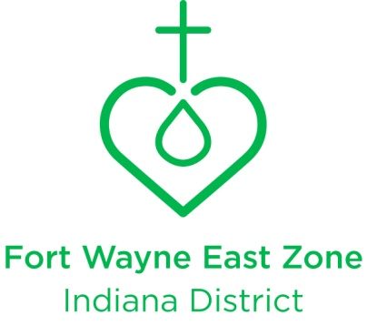

**Board of Directors - 2021-2022**

President **Cathie Wakeland** 3606 Oak Park Dr Fort Wayne, IN 46815-4714

(New Life) 348-3061 [wakelandcj@hotmail.com](mailto:wakelandcj@hotmail.com)

Past President **Elaine Nahrwold** 21515 Ward Rd Woodburn, IN 46797-9674

(Ascension) 632-4107 [dfnvet@reagan.com](mailto:dfnvet@reagan.com)

Vice-President **Karen Fuelling** 4256 E 1100 N Decatur, IN 46733-7167

(Emanuel) 438-9940 [antigogiel@gmail.com](mailto:antigogiel@gmail.com)

Secretary-Treasurer **Renee Schuller** 4727 N. Webster Rd New Haven, IN 46774-9557

(Emanuel) 418-4645 [reneeschuller.rs@gmail.com](mailto:reneeschuller.rs@gmail.com)

Pastoral Counselor **Rev. James Keller** 2424 S Coliseum Blvd Fort Wayne, IN 46803-2940

(New Life) 420-3024 [magisterjk@gmail.com](mailto:magisterjk@gmail.com)

Ascension **Judy Huber**  6002 Deer Track Cv Auburn, IN 46706-9324

402-7593 [judithhuber56@yahoo.com](mailto:judithhuber56@yahoo.com)

Christ **Diane Sargent** 3228 Fahlsing Rd Woodburn, IN 46797-9448

760-6586 [sewingmice@frontier.com](mailto:sewingmice@frontier.com)

Concordia **Sally Nyland** 1919 Huffman Blvd Fort Wayne, IN 46808-2211

420-6118 [sallyrob@frontier.com](mailto:sallyrob@frontier.com)

Emanuel **Renee Schuller** 4727 N. Webster Rd New Haven, IN 46774-9557

418-4645 [reneeschuller.rs@gmail.com](mailto:reneeschuller.rs@gmail.com)

Martini **Sue Teasdale**  245 E Pettit Ave Fort Wayne, IN 46806-3004

602-5022 [sue@coldwellhomes.com](mailto:sue@coldwellhomes.com)

New Life **Michele Yamanaka** 4336 Charter Ln Fort Wayne, IN 46815-7104

424-5070 cell 450-6422 [yamanakam@cs.com](mailto:yamanakam@cs.com)

Prince of Peace **Carol Miller** 4001 Meter Dr Fort Wayne, IN 46806-1644

493-0481 [csm49@aol.com](mailto:csm49@aol.com)

St. Paul **Brenda Schuller** 3728 Webster Rd Woodburn, IN 46797-9571

749-0169 [rschuller7640@gmail.com](mailto:rschuller7640@gmail.com)

St. Peter **Elise Koenemann** 8715 Middleboro Pl New Haven, IN 46774-1099

493-3923 [celerysoup@frontier.com](mailto:celerysoup@frontier.com)

Zion **Gladys Thiele** 1515 Dunnagans Way New Haven, IN 46774-3425

748-0115 – cell 249-8177 [ggthiele3@frontier.com](mailto:ggthiele3@frontier.com)

**LWML INDIANA DISTRICT 2020 -2022 MISSION GRANTS - $124,000**

**Small Grants –$5,000 and Under**

Jared LLC K-9 Comfort Dog Ministry $4,000

Little Disciples Day Camp Suburban Bethlehem, Fort Wayne 5,000

Rebecca’s Garden of Hope, Indianapolis 5,000

Team Trifa, Bringing the Gospel to Romania 5,000

The Shepherd's Hand Community Outreach Center, Fort Wayne 5,000

**Large Grants - Over $5,000**

Concordia Theological Seminary Food Co-op $10,000

Worship Anew/Lutheran Ministries Media, Inc 10,000

LWML Indiana District Scholarships 10,000

Mission Team Grants for Church Workers - MOST Ministries 10,000

Concordia Seminary Food Bank, St. Louis 10,000

LAMP Ministry Inc 10,000

Lutheran Agency for Missions to Burmese (LAMB) 10,000

Lutherans for Life - Y4Life in Washington, DC 10,000

Concordia Educational Association, Inc. Fort Wayne 10,000

Biblical Counselor Training - Puerto Rico 10,000

**Send mites to** LWML Indiana District Financial Secretary

Arlene Wolfgang 440 S 325 E Lagro IN 46941-9528

Contact Arlene for remittance forms. [arlene.kay47@gmail.com](mailto:arlene.kay47@gmail.com)

home 260-782-0429 cell 260-571-2577

**LWML 2021-2023 LWML MISSION GRANTS - MITE GOAL $2,150,000**

Deaconess Ministry Dakota Boys and Girls Ranch — Dakota Boys and Girls Ranch, $81,680

Healing the Invisible Wounds of War through Horses — Spirit Warrior, Central Maine, 95,000

Thirst to Learn: Bible Books for Africa's Children — Lutheran Heritage Foundation, 100,000

Making the Next Generation of Disciples for Life — LCMS Life Ministry, 92,000

Helping Hands for Lutheran Deaf Outreach — Lutheran Deaf Outreach, 50,000

Hope of Christ for Cancer Patients — Phil's Friends, 70,000

Training Pastors to Serve the Church in Russia — Lutheran Theological Seminary, Russia 100,000

Light of Christ in Eastern Europe — Mission Central, 56,000

Propelling the Gospel — LAMP Ministry, Inc., 65,000

Educating Pastors in Africa — Mission Central, 100,000

Redeeming Life Maternity Home, Illinois Expansion — Redeeming Life Outreach Ministries 100,000

Mercy Medical Care for Tanzania — Mwadui Lutheran School and Community, 68,182

Gospel Outreach to Women and Children in Mongolia — Lutheran Hour Ministries, 100,000

Caring for and Sharing Christ with Hurting People — Concordia Seminary, St. Louis, 100,000

The Littlest and Least of These — St. Paul Lutheran Church & Christian Academy, Dallas, TX 42,000

Bring the Inner-City Children to Camp — Lutheran Valley Retreat, Colorado, 25,000

Spiritual and Physical Food for Children of Peru — La Mision Luterana del Peru, 56,750

“Ends of Earth” Scholarships — Mission Opportunities Short Term (MOST) Ministries, 50,000

Sharing Jesus' Love in India — Lutheran Braille Workers, 100,000

Mission & Outreach to the Least of These — Victory Lutheran Church, 51,356

Mercy House Belize Lutheran Campus — Belize Mission Society, 100,000

Ministry Vehicle Fund, Ethiopia, and Sierra Leone — Lutheran Bible Translators, 70,000

Showing God's Love in the International District, Albuquerque, New Mexico — 98,000

Reaching the Homebound with God's Word — Lutheran Ministries Media (Worship Anew) 100,000

Missionaries to America Project — Mission Nation Publishing, 88,000

Strengthening the Lutheran Mission to Kuna, Idaho - Friendship Celebration Luth. Ch. 100,000

Expanding God’s Love in Uganda — LCMS Office of International Mission, Africa Regio, 92,000

Christ-Centered Materials for Hmong Language School and Outreach - St. Paul Outreach 70,208